FOR IMMEDIATE RELEASE CONTACT: Kim Ina
(415) 566-3487

SPORTS FOR THE WORLD’S CHILDREN TO HOST 9TH ANNUAL “THEY ARE WORTHY” BENEFIT SOFTBALL TOURNAMENT

SAN FRANCISCO, May 18, 2006 – The Sports for the World’s Children Foundation (SWC) will host its 9th annual “They Are Worthy” benefit softball tournament the weekend of July 8 and 9 at Moscone (Saturday) and Jackson (Sunday) Playgrounds in San Francisco. Format will be round robin and/or double elimination for the coed comp and rec divisions, and men’s DD/C divisions. Participants are asked to bring any used and new sports equipment to support their cause: All donated equipment and proceeds from the tournament go to providing kids (and communities and schools) with much needed sports equipment, facilities, skills clinics, and mentoring programs. Equipment needed includes baseballs, bases, basketballs, bats, batting gloves, catchers' gear, hats, mitts, soccer balls, softballs, sports trading cards, sports uniforms, volleyballs, etc. (See posting on www.swcfoundation.org.)

Last year a total of 18 teams participated in the tournament, and participants donated several hundred pounds of sports equipment. This equipment was later transported to communities in Mexico, and delivered directly to hundreds of children in dire needs of sports equipment through SWC’s “Communities Play” sports equipment distribution and volunteer program in December of 2005. Eleven volunteers from California, Washington, New Mexico, and Ohio traveled to Mexico to help with the sports equipment distribution effort, and Alaska Airlines provided all the extra cargo space needed transport the equipment.

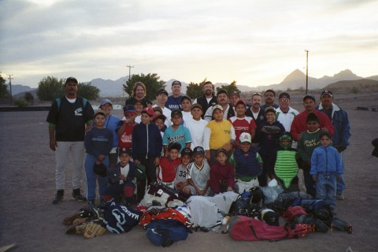

Equipment donations in Loreto, Baja California Sur, Mexico, December 5, 2005.

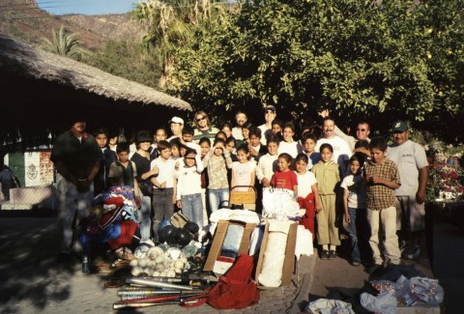

Equipment donations in San Javier, a community outside of Loreto, Baja California Sur, Mexico, Dec. 6, 2005.

The Sports for the World’s Children Foundation (SWC), based in San Francisco, has been a long time supporter of youth participation in sports in California and Mexico. SWC’s mission is to create ongoing, self-sustaining quality sports programs for children with limited or no resources. Over the past eight years, SWC has benefited more than 10,600 children, ages 5-18, by providing them with thousands of pounds of sports equipment and sports skills instruction and training through its “Communities Play” Program.

Interested individuals and/or sponsors can contact SWC for more information about the benefit softball tournament, their sports equipment distribution/volunteer program to Mexico in October/November 2006, and/or to order a DVD about their program at swc@swcfoundation.org, (415) 566-3487.

# # #

